Bahria University,

Karachi Campus



COURSE: CSC-110 COMPUTING FUNDAMENTALS

TERM: FALL 2022, CLASS: BSE- 1(B)

Submitted By:

02-131222-099

ABDULLAH

_______________________________________________

(Name) (Reg. No.)

Submitted To:

Engr. Rahemeen Khan

Signed Remarks: Score:

INDEX

|  |  |  |  |  |
| --- | --- | --- | --- | --- |
| SNO | DATE | LAB NO | LAB OBJECTIVE | SIGN |
|  |  |  |  |  |
|  |  |  |  |  |
|  |  |  |  |  |
|  |  |  |  |  |
|  |  |  |  |  |
|  |  |  |  |  |
|  |  |  |  |  |
|  |  |  |  |  |
|  |  |  |  |  |
|  |  |  |  |  |
|  |  |  |  |  |
|  |  |  |  |  |
|  |  |  |  |  |
|  |  |  |  |  |
| SNO | DATE | LAB NO | LAB OBJECTIVE | SIGN |
|  |  |  |  |  |
|  |  |  |  |  |
|  |  |  |  |  |
|  |  |  |  |  |
|  |  |  |  |  |
|  |  |  |  |  |
|  |  |  |  |  |
|  |  |  |  |  |
|  |  |  |  |  |
|  |  |  |  |  |
|  |  |  |  |  |
|  |  |  |  |  |
|  |  |  |  |  |
|  |  |  |  |  |
|  |  |  |  |  |

Bahria University,

Karachi Campus



LAB EXPERIMENT NO.

01

_______

LIST OF TASKS

|  |  |
| --- | --- |
| TASK NO | OBJECTIVE |
|  |  |
| 01 | Design layouts for input output storage devices. |
| 02 | To create an Advertisement. |
| 03 | Draw a Pie Chart to show a percent of PC operating profit 2016 with a different color, design and percentage choice, Format data labels and legend labels. |
| 04 | Draw a cycle process through word smart art which include your daily routine. |
| 05 | Create a word document that include Biography, Best childhood memory, Inspiration, Favorite sports, Position in next 5 Years, Social Networking Sites/links. |
| 06 | Apply Mail merge on a congratulations letter to the employee for getting new job. Add different fields and send it to friend |
|  |  |
|  |  |
|  |  |
|  |  |
|  |  |
|  |  |
|  |  |
|  |  |

Submitted On:

/10/22

____________

(Date: DD/MM/YY)

Lab Tasks

Task #01: Design layouts for input output storage devices.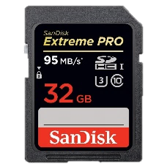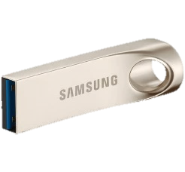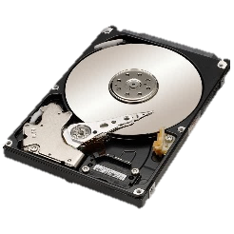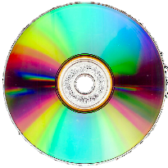

Can you think of any other Storage devices?

SD Card

CD/DVD Drive

USB Drive

Hard Disk

Storage Devices are used to record (Store) data

Storage Devices

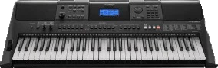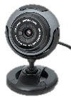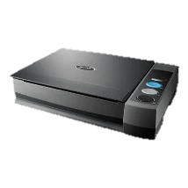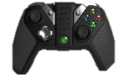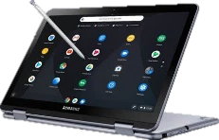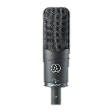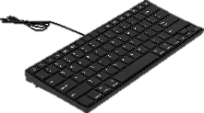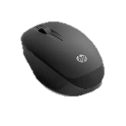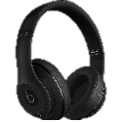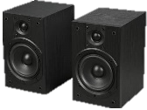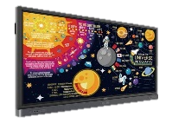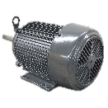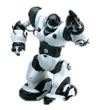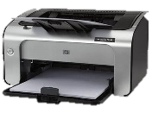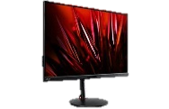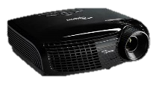

Musical Instruments

Webcams

Scanner

Game Controller

Touch Screens

Microphone

Keyboard

Mouse

Can you think of any other input Devices?

Input Devices

Input Devices send data and control signals to the computer.

Headphones

Speakers

Interactive Board

Motor

Can you think of any other Output Devices?

Robot

Printer

Projector

Monitor

Output devices communicate the results of proceeded data.

Output Devices

Task # 02: To create an Advertisement.

COMPUTER SLOW?

Task # 03: Draw a pie chart to show a percent of PC operating profit 2016 with a different color, design and percentage choice, Format data labels and legend labels.

**http://www.trimegatech.com**

Servicing Anne Arundel and Howard Country. We come to you.

410-280-1780

trimegatech

Network setup, new office setup, web design, web development, servers, etc.

**For small mid-sized business**

FREE CONSULATION

**Take advantage of our grand opening** **50% off** **sale. IT only happens once.**

Anti-Virus/spyware removal, pc repair, backup wireless networks, hardware upgrade, vista, etc

**All Services for home users**

50% Off

**We offer technology solutions and support for home users, home offices, and small-mid sized businesses.**

Task # 04: Draw a Cycle Process through word smart art which include Daily Routine.

**Task # 05:** Create a word document that include following headings:

1. My biography
2. My best childhood memory
3. My inspiration
4. My favorite sports
5. Where do I see myself in five years?
6. My social Networking Sites/links

**Solution:**

1. My Biography:

My name is Abdullah Sadiq. My father name is Muhammad Sadiq. I am 17 years old. I have passed 10th from E.A.B PN Secondary School Karachi. I have done my FSC from Bahria College NORE-1. I am studying Software Engineering at Bahria University Karachi. My home town is Faisalabad but I am currently living in Karachi. My hobby is Photography.

1. My best childhood memory:

I still remember the day when I was 7 years old, my Father gifted me a Brand New Bicycle. I was so excited to ride it because it was a totally new experience for me. And this is one of the best childhood memory I can’t forget.

1. My inspiration:

I am extremely inspired by my Father. My Father is an inspiration for me. Whenever I feel dull or depressed, I just think about the efforts he has done for us and he is still doing. He has taught me the toughest lessons of life. He is an ideal for me and I am nothing without my father.

1. My favorite sports:

**“Honesty is a great policy”.** To be honest, I don’t have any interest in sports. But as we know **“Healthy body has a healthy mind”.** So, to maintainfitness I prefer running. I wake up early in the morning and start running.

1. Where do I see myself in Five year:

After Five years, I see myself as a Skilled Software Developer performing his Best to Digitalize Pakistan and making every possible effort to represent Pakistan in a positive way.

1. My Social Networking Sites:

**All of my Social Media Handles:**

[**Email**](mailto:abdullahsadiq0701@gmail.com)

[**Facebook**](https://facebook.com/as.capturess)

[**Instagram**](https://instagram.com/abdullah.sadiq._)

**Task # 06:** Apply mail merge on a letter.

**Solution:** 